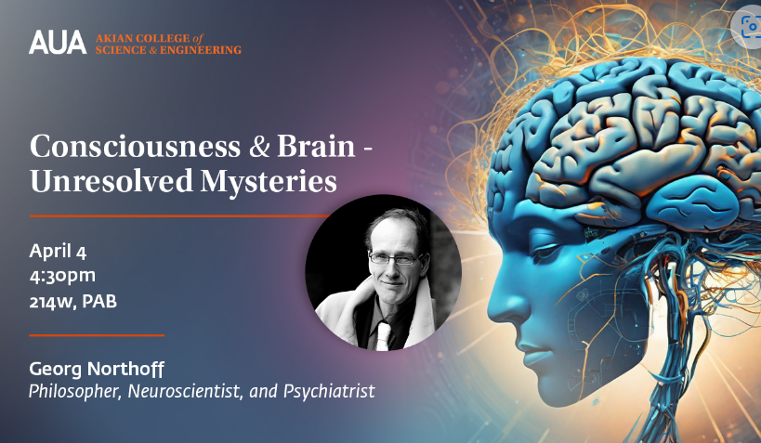
Dear AUA Community,

We would like to invite you to join us for the “Consciousness and the Brain: Unresolved Mysteries” lecture featuring a distinguished guest, Dr. Georg Northoff, philosopher, neuroscientist, and psychiatrist, from the University of Ottawa, Canada. Dr. Northoff is the author of various books, including his recent Neurowaves - Brain, Time and Consciousness. His official website is accessible at: www.georgnorthoff.com, while the published articles and books can be found at: http://www.georgnorthoff.com/books.

During his insightful lecture, Dr. Northoff will delve into the unresolved mysteries of the brain by exploring its unique structure and the mechanisms behind consciousness. The lecture will also address whether artificial intelligence, like robots, can possess a conscious mind.

Before the lecture, we encourage you to watch Dr. Northoff’s “Do Robots and Artificial Intelligence Have Consciousness? A View from the Brain” online seminar from last year, accessible here.

Save the date to join us on April 4 at 4:30pm in Room 214W, PAB.

Register here.
Best regards,
Akian College of Science and Engineering (CSE) Administration
+374 60 612553

